
A Multi-Vendor B2C E-Commerce Marketplace

Project Report
Submitted in Partial Fulfillment of the Requirement for the Course
Full Stack Java Development

Submitted By:
Mahesh Selukar

Submitted To:
TOPS Technologies

Date of Submission:
25 February, 2026

CERTIFICATE

This is to certify that Mr. Maheshkumar Selukar has successfully completed the project titled 'ShopNexa – A Multi-Vendor B2C E-Commerce Marketplace' as part of the Full Stack Java Development course at TOPS Technologies.
The project work is a genuine record of his efforts and has been completed under proper guidance and supervision.

_________________________
Trainer Signature
_________________________
Center Head Signature

TABLE OF CONTENTS
1. Introduction
2. Abstract
3. System Overview
4. Modules Description
5. System Architecture
6. Database Design
7. Use Case Diagram
8. DFD Diagram

1. Introduction

B2C-Portal is a multi-vendor Business-to-Consumer (B2C) e-commerce platform designed to automate and streamline online retail business operations. In traditional retail systems, transaction management, stock tracking, and sales recording are handled manually, which is time-consuming and prone to errors. With the rapid growth of digital commerce, managing large volumes of transactions has become increasingly complex.
The proposed B2C-Portal provides a centralized online marketplace where vendors can register, manage products, update inventory, and monitor sales, while customers can browse categories, search products, add items to cart, place orders, track shipments, and make secure online payments.
The system includes advanced features such as vendor management, catalog management, inventory tracking, secure payment processing, mailing support, and administrative reporting. The portal ensures data security, role-based access control, and efficient transaction processing, making it suitable for modern e-commerce business environments.
The main objective of the system is to provide a scalable, secure, and automated solution for managing online retail transactions efficiently.

2. Abstract

B2C (Business-to-Consumer) refers to commercial transactions that take place directly between a business and the end consumer. In today’s rapidly expanding retail industry, managing high volumes of customer transactions, product inventory, and sales data manually is inefficient and error-prone. The B2C-Portal project aims to automate and simplify retail operations through an online multi-vendor marketplace system.
The platform enables vendors to sell products online while customers can browse items, manage shopping carts, place orders, and track purchases. The system maintains complete records of orders, customer history, product inventory, and sales statistics within a centralized database.
The portal integrates advanced modules such as Customer Service Center, Mailing Support, and Website Administration. It supports secure payment options, advanced product search, custom reporting, loyalty programs, and administrative controls to prevent unauthorized activities. The system enhances transaction transparency, improves operational efficiency, and provides a modern digital retail solution.

3. System Overview
The B2C-Portal is designed as a web-based multi-vendor e-commerce system consisting of three primary user roles:
3.1. Customer Module
Customers can:
- Register and login securely
- Browse products by category and sub-category
- Use simple and advanced search functionality
- Add products to shopping cart
- Place orders with secured payment options
- Track order status
- View order history
- Join mailing list
- Receive email notifications for registration, password reset, and order updates
- Avail loyalty discounts and customer-based offers
The system stores complete customer order history and enables repeat customer recognition.
3.2. Vendor Module
Vendors can:
- Register and manage their product listings
- Add, update, or delete products
- Manage inventory and stock levels
- Upload product images and descriptions
- View customer reviews
- Receive email notifications for product reviews
- Monitor sales reports and statistics
3.3. Admin Module
The administrator has full control over the system and can:
- Manage vendors and customers
- Approve or decline orders
- Manage categories and subcategories
- Control unlimited product listings
- Monitor total sales and product-wise sales
- Generate custom reports (Sales reports, Search query reports, Abandoned cart reports)
- Block suspicious IP addresses or emails
- Restrict orders from specific countries
- Maintain system security and prevent SQL injection
- Manage mailing services and notifications
3.4. Mailing Support System
The system automatically sends emails for:
- New customer registration
- Password change or forgot password
- Order placement confirmation
- Order approval or rejection
- Product review notifications
- “Tell a Friend” feature
3.5 Core Features Summary
- Shopping Cart System
- Vendor Management
- Product & Category Management
- Inventory Tracking
- Order Tracking
- Secure Payment Options
- Content Management System
- Custom Reporting & Statistics
- Advanced Search Facility
- Security Controls & Access Management

4. Modules Description
The B2C-Portal system is divided into multiple functional modules to ensure proper management of users, products, transactions, and system administration. Each module performs specific responsibilities to maintain smooth e-commerce operations.
4.1 Customer Module
This module handles all activities related to customers.
Functions:
- Customer Registration & Login
- Secure Authentication
- Browse Products by Category/Subcategory
- Advanced Product Search
- Add to Cart / Remove from Cart
- Checkout & Secure Payment
- Order Placement
- Order Tracking
- View Order History
- Apply Discounts & Loyalty Offers
- Join Mailing List
- Receive Email Notifications
Purpose:
To provide a smooth and secure shopping experience for customers.
4.2 Vendor Module
This module allows vendors (sellers) to manage their products and monitor sales.
Functions:
- Vendor Registration & Login
- Product Add / Update / Delete
- Upload Product Images
- Set Product Price & Stock
- Manage Inventory
- View Orders Related to Their Products
- View Customer Reviews
- Generate Sales Reports
- Receive Email Notifications (New Orders / Reviews)
Purpose:
To enable vendors to independently manage and sell their products on the platform.
4.3 Admin Module
The Admin Module is the control center of the system.
Functions:
- Manage Customers
- Manage Vendors
- Approve / Reject Vendors
- Manage Categories & Subcategories
- Manage Products
- Approve / Decline Orders
- Monitor Sales Reports
- View Product-wise Sales
- View Total Revenue
- Block Suspicious Users (IP / Email)
- Restrict Country-based Orders
- Manage CMS Content
- Maintain Security Controls
Purpose:
To maintain overall system control, monitoring, and security.
4.4 Product & Catalog Management Module
This module manages product structure and hierarchy.
Functions:
- Create Unlimited Categories
- Create Subcategories (Multiple Depth Levels)
- Assign Products to Categories
- Manage Product Descriptions
- Upload Thumbnails & Large Images
- Automated Extended Descriptions
Purpose:
To organize products systematically for better browsing and search.
4.5 Inventory Management Module
This module tracks product stock levels.
Functions:
- Update Stock Quantity
- Auto Stock Reduction After Order
- Out-of-Stock Notification
- Inventory Alerts to Vendor
- Inventory Reports
Purpose:
To prevent overselling and manage product availability efficiently.
4.6 Shopping Cart & Order Management Module
This module handles order processing.
Functions:
- Add Multiple Products in Cart
- Update Quantity
- Calculate Total Amount
- Apply Discounts
- Generate Order ID
- Store 0Orders in Database
- Order Status Tracking
- Abandoned Cart Tracking
Purpose:
To manage complete order lifecycle from cart to delivery.
4.7 Payment Module
This module ensures secure financial transactions.
Functions:
- Secure Payment Gateway Integration
- Multiple Payment Options (Card, UPI, COD)
- Payment Status Tracking
- Invoice Generation
- Payment Confirmation Email
Purpose:
To ensure safe and verified transactions between customer and vendor.
4.8 Mailing Support Module
This module handles automated email communication.
Functions:
- Mail After Registration
- Mail After Password Change
- Forgot Password Mail
- Order Confirmation Mail
- Order Approval / Rejection Mail
- Review Notification Mail
- Tell-a-Friend Feature
- Mailing List Support
Purpose:
To maintain proper communication between system, customers, vendors, and admin.
4.9 Reporting & Statistics Module
This module generates analytical reports.
Functions:
- Total Sales Report
- Product-wise Sales Report
- Vendor Sales Report
- Search Query Report
- Abandoned Cart Report
- First Page Visit Count
- Revenue Analysis
Purpose:
To provide data insights for business decision-making.

5. System Architecture
5.1 Architecture Overview
The B2C-Portal follows a Three-Tier Architecture (Presentation Layer, Business Logic Layer, and Data Layer) combined with a RESTful API-based client-server architecture.
The system is designed using a decoupled frontend and backend structure, where:
- The Frontend (React.js) handles UI and user interaction.
- The Backend (Spring Boot) provides REST APIs for business logic.
- The Database (MySQL) stores all system data.
- The system supports secure communication and role-based access control.
5.2 Architecture Layers
1️. Presentation Layer (Frontend)
Technology Used: React.js, HTML5, CSS3, Bootstrap
Responsibilities:
- User Interface (Customer, Vendor, Admin dashboards)
- Product listing & search
- Cart management
- Form validation
- API calls using Axios / Fetch
- Display order tracking status
- Responsive design
This layer communicates with backend APIs using HTTP requests (GET, POST, PUT, DELETE).
2️. Business Logic Layer (Backend)
Technology Used: Spring Boot, Hibernate (JPA)
Responsibilities:
- Authentication & Authorization
- Role-Based Access Control (Admin, Vendor, Customer)
- Product Management Logic
- Category Management
- Order Processing
- Payment Processing Integration
- Mailing Service
- Inventory Management
- Report Generation
- Security Validation
Spring Boot exposes RESTful APIs which are consumed by the frontend.
3️. Data Layer (Database)
Technology Used: MySQL
Responsibilities:
- Store Customer Data
- Store Vendor Data
- Store Product & Category Data
- Store Orders & Payment Records
- Store Inventory Data
- Store Mailing Logs
- Store Reports Data
Hibernate (JPA) is used for ORM mapping between Java objects and database tables.
5.3 System Architecture Diagram (Conceptual Flow)
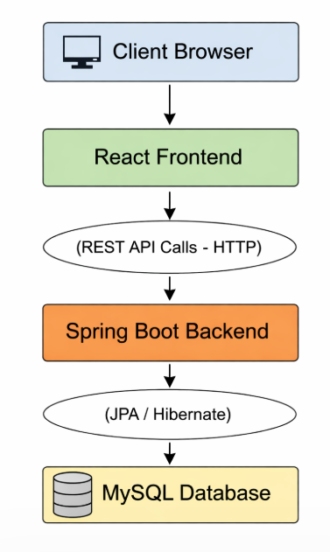
Optional Components:
- Payment Gateway API
- Email Server (SMTP)
- JWT Authentication Layer
5.4 Request Flow Example (Order Placement)
Step-by-step working:
- Customer adds product to cart (Frontend).
- React sends POST request to /api/orders.
- Spring Boot validates user & stock.
- Order saved in database.
- Payment API is triggered.
- Payment status updated.
- Confirmation email sent.
- Order status returned to frontend.
5.5 Security Architecture
- Role-Based Access Control
- JWT Token Authentication
- Password Encryption
- SQL Injection Prevention
- Input Validation
- Hidden Admin Panel
- IP & Country Blocking

6. Database Design
6.1 Users Module
Column | Type | Description
user_id | INT PK AUTO_INCREMENT | Unique user ID
name | VARCHAR(100) NOT NULL | User name
email | VARCHAR(100) UNIQUE | User email
password | VARCHAR(255) NOT NULL | User password
role | ENUM('ADMIN','VENDOR','CUSTOMER') | User role
phone | VARCHAR(15) | User phone
created_at | TIMESTAMP DEFAULT CURRENT_TIMESTAMP | Creation time

user_id | name | email | password | role | phone
1 | Mahesh Admin | admin@gmail.com | admin123 | ADMIN | 9773272969
2 | Vendor One | vendor1@ gmail.com | vendor123 | VENDOR | 9876543210
3 | Customer One | customer1@ gmail.com | cust123 | CUSTOMER | 9123456780
Purpose: Handle Admin, Vendor, Customer.

Table: users
CREATE TABLE users (
user_id INT PRIMARY KEY AUTO_INCREMENT,
name VARCHAR(100) NOT NULL,
email VARCHAR(100) UNIQUE NOT NULL,
password VARCHAR(255) NOT NULL,
role ENUM('ADMIN','VENDOR','CUSTOMER') NOT NULL,
phone VARCHAR(15),
created_at TIMESTAMP DEFAULT CURRENT_TIMESTAMP
);
Sample Insert:
INSERT INTO users (name,email,password,role,phone)
VALUES
('Mahesh Admin','admin@shopnexa.com','admin123','ADMIN','9773272969'),
('Vendor One','vendor1@shopnexa.com','vendor123','VENDOR','9876543210'),
('Customer One','customer1@shopnexa.com','cust123','CUSTOMER','9123456780');

6.2️. Customer Address Module
Column | Type | Description
address_id | INT PK AUTO_INCREMENT | Unique address ID
customer_id | INT NOT NULL | FK to users(user_id)
address_line1 | VARCHAR(255) NOT NULL | Flat/House Number
address_line2 | VARCHAR(255) | Building/Society
landmark | VARCHAR(255) | Optional landmark
City | VARCHAR(100) | City
State | VARCHAR(100) | State
pincode | VARCHAR(10) | Postal code
country | VARCHAR(50) | Country
latitude | DECIMAL(10,8) | Google latitude
longitude | DECIMAL(11,8) | Google longitude

address_id | customer_id | address_line1 | address_line2 | landmark | city | state | pincode | country | latitude | longitude
1 | 3 | Flat 101 | Sunshine Society | Near City Mall | Ahmedabad | Gujarat | 380015 | India | 23.0225 | 72.5714
2 | 3 | House 12 | Green Park | Opposite Hospital | Ahmedabad | Gujarat | 380016 | India | 23.0250 | 72.5720

Purpose: Store full address + Google lat/lng

Table: customer_addresses
CREATE TABLE customer_addresses (
address_id INT PRIMARY KEY AUTO_INCREMENT,
customer_id INT NOT NULL,
address_line1 VARCHAR(255) NOT NULL, -- Flat/House Number
address_line2 VARCHAR(255), -- Building/Society
landmark VARCHAR(255), -- Optional landmark
city VARCHAR(100),
state VARCHAR(100),
pincode VARCHAR(10),
country VARCHAR(50),
latitude DECIMAL(10,8), -- Google API latitude
longitude DECIMAL(11,8), -- Google API longitude
FOREIGN KEY (customer_id) REFERENCES users(user_id)
);
Sample Insert:
INSERT INTO customer_addresses
(customer_id,address_line1,address_line2,landmark,city,state,pincode,country,latitude,longitude)
VALUES
(3,'Flat 101','Sunshine Society','Near City Mall','Ahmedabad','Gujarat','380015','India',23.0225,72.5714);

6.3️ Category Module
Column | Type | Description
category_id | INT PK AUTO_INCREMENT | Unique category ID
name | VARCHAR(100) NOT NULL | Category name
parent_id | INT DEFAULT NULL FK | Parent category
created_by | INT FK users(user_id) | Admin who created

category_id | name | parent_id | created_by
1 | Electronics | NULL | 1
2 | Clothing | NULL | 1
3 | Mobile Phones | 1 | 1
4 | Laptops | 1 | 1
5 | Men | 2 | 1
6 | Women | 2 | 1

Purpose: Multi-level categories/subcategories

Table: categories
CREATE TABLE categories (
category_id INT PRIMARY KEY AUTO_INCREMENT,
name VARCHAR(100) NOT NULL,
parent_id INT DEFAULT NULL,
created_by INT,
FOREIGN KEY (parent_id) REFERENCES categories(category_id),
FOREIGN KEY (created_by) REFERENCES users(user_id)
);
Sample Insert:
-- Main categories
INSERT INTO categories(name,parent_id) VALUES
('Electronics',NULL),
('Clothing',NULL),
('Home & Kitchen',NULL);
-- Subcategories
INSERT INTO categories(name,parent_id) VALUES
('Mobile Phones',1),
('Laptops',1),
('Men',2),
('Women',2);

6.4️ Product Module
Column | Type | Description
product_id | INT PK AUTO_INCREMENT | Unique product ID
vendor_id | INT NOT NULL FK users(user_id) | Vendor ID
category_id | INT NOT NULL FK categories(category_id) | Category ID
name | VARCHAR(150) NOT NULL | Product name
description | TEXT | Product description
price | DECIMAL(10,2) | Product price
stock_qty | INT DEFAULT 0 | Quantity available
approval_status | ENUM('PENDING','APPROVED','REJECTED') DEFAULT 'PENDING' | Admin approval status
created_at | TIMESTAMP DEFAULT CURRENT_TIMESTAMP | Product added date

product_id | vendor_id | category_id | name | description | price | stock_qty | approval_status
1 | 2 | 5 | Men T-Shirt | Cotton T-Shirt | 499 | 100 | PENDING
2 | 2 | 3 | iPhone 14 | Apple iPhone 14 | 99999 | 50 | PENDING
3 | 2 | 4 | Dell Laptop | Core i7 Laptop | 55000 | 30 | PENDING

Purpose: Vendor products, pending admin approval

Table: products
CREATE TABLE products (
product_id INT PRIMARY KEY AUTO_INCREMENT,
vendor_id INT NOT NULL,
category_id INT NOT NULL,
name VARCHAR(150) NOT NULL,
description TEXT,
price DECIMAL(10,2),
stock_qty INT DEFAULT 0,
approval_status ENUM('PENDING','APPROVED','REJECTED') DEFAULT 'PENDING',
created_at TIMESTAMP DEFAULT CURRENT_TIMESTAMP,
FOREIGN KEY (vendor_id) REFERENCES users(user_id),
FOREIGN KEY (category_id) REFERENCES categories(category_id)
);

Sample Insert:
INSERT INTO products(vendor_id,category_id,name,description,price,stock_qty)
VALUES
(2,5,'Men T-Shirt','Cotton T-Shirt',499,100),
(2,3,'iPhone 14','Apple iPhone 14',99999,50),
(2,4,'Dell Laptop','Core i7 Laptop',55000,30);

6.5️ Reviews Module
Column | Type | Description
review_id | INT PK AUTO_INCREMENT | Unique review ID
product_id | INT NOT NULL | FK to products(product_id)
customer_id | INT NOT NULL | FK to users(user_id)
rating | INT NOT NULL | 1-5 star rating
feedback | TEXT | Customer feedback
created_at | TIMESTAMP DEFAULT CURRENT_TIMESTAMP | Review date

review_id | product_id | customer_id | rating | feedback
1 | 1 | 3 | 5 | Excellent quality T-shirt!
2 | 2 | 3 | 4 | Good phone, fast delivery.

Purpose: Product rating & feedback

Table: reviews
CREATE TABLE reviews (
review_id INT PRIMARY KEY AUTO_INCREMENT,
product_id INT NOT NULL,
customer_id INT NOT NULL,
rating INT NOT NULL, -- 1-5 stars
feedback TEXT,
created_at TIMESTAMP DEFAULT CURRENT_TIMESTAMP,
FOREIGN KEY (product_id) REFERENCES products(product_id),
FOREIGN KEY (customer_id) REFERENCES users(user_id)
);
Sample Insert:
INSERT INTO reviews(product_id,customer_id,rating,feedback)
VALUES
(1,3,5,'Excellent quality T-shirt!');

6.6 Cart Module
Column | Type | Description
cart_item_id | INT PK AUTO_INCREMENT | Unique cart item
customer_id | INT NOT NULL | FK to users(user_id)
product_id | INT NOT NULL | FK to products(product_id)
quantity | INT DEFAULT 1 | Quantity
added_at | TIMESTAMP DEFAULT CURRENT_TIMESTAMP | Added date

cart_item_id | customer_id | product_id | quantity
1 | 3 | 1 | 2
2 | 3 | 2 | 1
3 | 3 | 3 | 1

Purpose: Temporary cart storage

Table: cart_items
CREATE TABLE cart_items (
cart_item_id INT PRIMARY KEY AUTO_INCREMENT,
customer_id INT NOT NULL,
product_id INT NOT NULL,
quantity INT DEFAULT 1,
added_at TIMESTAMP DEFAULT CURRENT_TIMESTAMP,
FOREIGN KEY (customer_id) REFERENCES users(user_id),
FOREIGN KEY (product_id) REFERENCES products(product_id)
);
Sample Insert:
INSERT INTO cart_items(customer_id,product_id,quantity)
VALUES
(3,1,2),
(3,2,1);

6.7️ Orders Module
Column | Type | Description
order_id | INT PK AUTO_INCREMENT | Unique order ID
customer_id | INT NOT NULL | FK to users(user_id)
address_id | INT NOT NULL | FK to customer_addresses
total_amount | DECIMAL(10,2) | Total order amount
distance_km | DECIMAL(10,2) | Distance from center
delivery_charge | DECIMAL(10,2) | Delivery charges
order_status | VARCHAR(50) DEFAULT 'Pending' | Order status
created_at | TIMESTAMP DEFAULT CURRENT_TIMESTAMP | Order date

order_id | customer_id | address_id | total_amount | distance_km | delivery_charge | order_status
1 | 3 | 1 | 1000 | 10 | 60 | Pending
2 | 3 | 2 | 1050 | 12 | 70 | Pending

order_item_id | order_id | product_id | vendor_id | quantity | Price
1 | 1 | 1 | 2 | 2 | 499
2 | 1 | 2 | 2 | 1 | 999
3 | 2 | 3 | 2 | 1 | 55000

Purpose: Store placed orders, distance & delivery charge
Main Table: orders
CREATE TABLE orders (
order_id INT PRIMARY KEY AUTO_INCREMENT,
customer_id INT NOT NULL,
address_id INT NOT NULL,
total_amount DECIMAL(10,2),
distance_km DECIMAL(10,2),
delivery_charge DECIMAL(10,2),
order_status VARCHAR(50) DEFAULT 'Pending',
created_at TIMESTAMP DEFAULT CURRENT_TIMESTAMP,
FOREIGN KEY (customer_id) REFERENCES users(user_id),
FOREIGN KEY (address_id) REFERENCES customer_addresses(address_id)
);

Child Table: order_items
Column | Type | Description
order_item_id | INT PK AUTO_INCREMENT | Unique item record
order_id | INT NOT NULL FK orders(order_id) | Order ID
product_id | INT NOT NULL FK products(product_id) | Product ID
vendor_id | INT NOT NULL FK users(user_id) | Vendor ID
Quantity | INT | Quantity ordered
Price | DECIMAL(10,2) | Product price

order_item_id | order_id | product_id | vendor_id | quantity | price
1 | 1 | 1 | 2 | 2 | 499
2 | 1 | 2 | 2 | 1 | 999
3 | 2 | 3 | 2 | 1 | 55000

CREATE TABLE order_items (
order_item_id INT PRIMARY KEY AUTO_INCREMENT,
order_id INT NOT NULL,
product_id INT NOT NULL,
vendor_id INT NOT NULL,
quantity INT,
price DECIMAL(10,2),
FOREIGN KEY (order_id) REFERENCES orders(order_id),
FOREIGN KEY (product_id) REFERENCES products(product_id),
FOREIGN KEY (vendor_id) REFERENCES users(user_id)
);
Sample Insert:
INSERT INTO orders(customer_id,address_id,total_amount,distance_km,delivery_charge)
VALUES
(3,1,1000,10,60);
INSERT INTO order_items(order_id,product_id,vendor_id,quantity,price)
VALUES
(1,1,2,2,499),
(1,2,2,1,999),
(2,3,2,1,55000);

6.8️ Mailing Support Module
Column Name | Data Type | Description
mail_id | INT PK AUTO_INCREMENT | Unique mail ID
order_id | INT (FK) | Related Order ID
customer_id | INT (FK) | Customer who receives mail
vendor_id | INT (FK) | Vendor (if applicable)
subject | VARCHAR(255) | Email subject
body | TEXT | Email body content
sent_at | TIMESTAMP DEFAULT CURRENT_TIMESTAMP | Mail sent time

mail_id | order_id | customer_id | vendor_id | subject | body | sent_at
1 | 1 | 3 | 2 | Order Placed | Your order #1 has been placed successfully. | 2026-02-23 12:05:00
2 | 1 | 3 | 2 | Order Dispatched | Your order #1 has been dispatched. | 2026-02-23 15:00:00
3 | NULL | 3 | NULL | Password Reset | Your password has been changed successfully. | 2026-02-22 10:00:00

Table: mails
CREATE TABLE mails (
mail_id INT PRIMARY KEY AUTO_INCREMENT,
order_id INT,
customer_id INT,
vendor_id INT,
subject VARCHAR(255),
body TEXT,
sent_at TIMESTAMP DEFAULT CURRENT_TIMESTAMP,
FOREIGN KEY (order_id) REFERENCES orders(order_id),
FOREIGN KEY (customer_id) REFERENCES users(user_id),
FOREIGN KEY (vendor_id) REFERENCES users(user_id)
);
Sample Insert:
INSERT INTO mails (order_id, customer_id, vendor_id, subject, body)
VALUES
(1, 3, 2, 'Order Placed', 'Your order #1 has been placed successfully.'),
(1, 3, 2, 'Order Dispatched', 'Your order #1 has been dispatched.'),
(NULL, 3, NULL, 'Password Reset', 'Your password has been changed successfully.');

6.9️ Payment Module
Column | Type | Description
payment_id | INT PK AUTO_INCREMENT | Unique payment ID
order_id | INT NOT NULL FK to orders(order_id) | Linked order
Amount | DECIMAL(10,2) | Payment amount
payment_method | ENUM('COD','Credit Card','UPI','Net Banking') | Payment type
payment_status | VARCHAR(50) | Paid / Pending
paid_at | TIMESTAMP DEFAULT CURRENT_TIMESTAMP | Payment date

payment_id | order_id | amount | payment_method | payment_status
1 | 1 | 1060 | COD | Paid
2 | 2 | 1050 | COD | Pending

Table: payments
CREATE TABLE payments (
payment_id INT PRIMARY KEY AUTO_INCREMENT,
order_id INT NOT NULL,
amount DECIMAL(10,2),
payment_method ENUM('COD','Credit Card','UPI','Net Banking'),
payment_status VARCHAR(50),
paid_at TIMESTAMP DEFAULT CURRENT_TIMESTAMP,
FOREIGN KEY (order_id) REFERENCES orders(order_id)
);

INSERT INTO payments(order_id,amount,payment_method,payment_status)
VALUES
(1,1060,'COD','Paid'),
(2,1050,'COD','Pending');

6.10 Vendor Commission Module

Purpose: Track vendor earnings & admin commission
Column | Type | Description
commission_id | INT PK AUTO_INCREMENT | Unique commission record
order_item_id | INT NOT NULL FK order_items(order_item_id) | Order item reference
vendor_id | INT NOT NULL FK users(user_id) | Vendor ID
product_amount | DECIMAL(10,2) | Product price
commission_percent | DECIMAL(5,2) | Admin commission %
commission_amount | DECIMAL(10,2) | Admin commission amount
vendor_earnings | DECIMAL(10,2) | Amount paid to vendor
created_at | TIMESTAMP DEFAULT CURRENT_TIMESTAMP | Record timestamp

Sample Data:
commission_id | order_item_id | vendor_id | product_amount | commission_percent | commission_amount | vendor_earnings
1 | 1 | 2 | 998 | 10 | 99.8 | 898.2
2 | 2 | 2 | 999 | 10 | 99.9 | 899.1

Query:
CREATE TABLE vendor_commission (
commission_id INT PRIMARY KEY AUTO_INCREMENT,
order_item_id INT NOT NULL,
vendor_id INT NOT NULL,
product_amount DECIMAL(10,2),
commission_percent DECIMAL(5,2),
commission_amount DECIMAL(10,2),
vendor_earnings DECIMAL(10,2),
created_at TIMESTAMP DEFAULT CURRENT_TIMESTAMP,
FOREIGN KEY (order_item_id) REFERENCES order_items(order_item_id),
FOREIGN KEY (vendor_id) REFERENCES users(user_id)
);

INSERT INTO vendor_commission(order_item_id,vendor_id,product_amount,commission_percent,commission_amount,vendor_earnings)
VALUES
(1,2,998,10,99.8,898.2),
(2,2,999,10,99.9,899.1);
6.11 Discount table:
Purpose: Store Customer-based, product-based, or category-based discounts.
Column | Type | Description
discount_id | INT PK AUTO_INCREMENT | Unique discount ID
discount_name | VARCHAR(100) NOT NULL | Name of discount (e.g., New Year Offer)
discount_type | ENUM('PERCENTAGE','FLAT') | Type of discount: percentage or flat amount
discount_value | DECIMAL(10,2) | Discount value (e.g., 10% or 100 Rs)
applicable_to | ENUM('CUSTOMER','PRODUCT','CATEGORY') | Discount applicable to customer/product/category
applicable_id | INT NULL | ID of customer/product/category
start_date | DATE | Start date of discount
end_date | DATE | End date of discount
created_at | TIMESTAMP DEFAULT CURRENT_TIMESTAMP | Record creation timestamp

discount_id | discount_name | discount_type | discount_value | applicable_to | applicable_id | start_date | end_date
1 | New Year Offer | PERCENTAGE | 10 | CATEGORY | 1 | 2026-01-01 | 2026-01-31
2 | VIP Customer | FLAT | 100 | CUSTOMER | 3 | 2026-02-01 | 2026-12-31

6.12 Loyalty Points Table
Purpose: Track points for Repeat customers.
Column | Type | Description
loyalty_id | INT PK AUTO_INCREMENT | Unique loyalty ID
customer_id | INT NOT NULL | Customer ID (FK users)
points_earned | INT DEFAULT 0 | Points earned by customer
points_redeemed | INT DEFAULT 0 | Points used by customer
last_updated | TIMESTAMP DEFAULT CURRENT_TIMESTAMP | Last update timestamp

loyalty_id | customer_id | points_earned | points_redeemed | last_updated
1 | 3 | 200 | 50 | 2026-02-23 12:00:00

6.13 Abandoned Carts Table
Purpose: To log the current status and updates of an order.
Column Name | Data Type | Description
abandoned_id | INT PK AUTO_INCREMENT | Unique record ID
customer_id | INT (FK) | Customer ID
cart_data | TEXT | Cart items in JSON format
abandoned_at | TIMESTAMP DEFAULT CURRENT_TIMESTAMP | Abandoned date & time

CREATE TABLE abandoned_carts (
abandoned_id INT PRIMARY KEY AUTO_INCREMENT,
customer_id INT NOT NULL,
cart_data TEXT NOT NULL,
abandoned_at TIMESTAMP DEFAULT CURRENT_TIMESTAMP,
FOREIGN KEY (customer_id) REFERENCES users(user_id)
);
abandoned_id | customer_id | cart_data | abandoned_at
1 | 3 | {"product_id":1,"quantity":2} | 2026-02-23 18:30:00
2 | 3 | {"product_id":2,"quantity":1} | 2026-02-23 19:10:00

INSERT INTO abandoned_carts (customer_id, cart_data)

VALUES

(3, '{"product_id":1,"quantity":2}'),

(3, '{"product_id":2,"quantity":1}')

6.14 Order Tracking Table
Purpose: To record and track the current status and updates of an order.
Column | Type | Description
tracking_id | INT PK AUTO_INCREMENT | Unique tracking ID
order_id | INT NOT NULL | Order ID (FK orders)
status_message | VARCHAR(255) NOT NULL | Order status message
updated_at | TIMESTAMP DEFAULT CURRENT_TIMESTAMP | Timestamp of status update

tracking_id | order_id | status_message | updated_at
1 | 1 | Order placed by customer | 2026-02-23 12:05:00
2 | 1 | Payment received | 2026-02-23 12:10:00
3 | 1 | Order dispatched | 2026-02-23 15:00:00
4 | 1 | Order delivered | 2026-02-24 10:00:00

6.15 Search Query Report Table
Purpose
To store and analyze customer search activity for reporting and analytics.
Column Name | Data Type | Description
search_id | INT (PK) | Unique search record ID
customer_id | INT (FK) | User who performed search
search_keyword | VARCHAR(255) | Keyword searched by user
category_id | INT (FK) | Category in which search was made
result_count | INT | Number of products found
user_ip | VARCHAR(45) | User IP address
searched_at | TIMESTAMP | Search time
CREATE TABLE search_logs (
search_id INT PRIMARY KEY AUTO_INCREMENT,
customer_id INT,
search_keyword VARCHAR(255) NOT NULL,
category_id INT,
result_count INT DEFAULT 0,
user_ip VARCHAR(45),
searched_at TIMESTAMP DEFAULT CURRENT_TIMESTAMP,
FOREIGN KEY (customer_id) REFERENCES users(user_id),
FOREIGN KEY (category_id) REFERENCES categories(category_id)
);
search_id | customer_id | search_keyword | category_id | result_count | user_ip | searched_at
1 | 2 | iPhone 15 | 1 | 5 | 192.168.1.10 | 2026-02-23 10:15:00
2 | 2 | Samsung Galaxy | 1 | 3 | 192.168.1.10 | 2026-02-23 10:18:00
3 | 3 | Wireless Earbuds | 2 | 8 | 192.168.1.25 | 2026-02-23 11:05:00
4 | 3 | Men T-Shirt | 5 | 12 | 192.168.1.25 | 2026-02-23 11:20:00

INSERT INTO search_logs
(customer_id, search_keyword, category_id, result_count, user_ip)
VALUES
(2, 'iPhone 15', 1, 5, '192.168.1.10'),
(2, 'Samsung Galaxy', 1, 3, '192.168.1.10'),
(3, 'Wireless Earbuds', 2, 8, '192.168.1.25');
6.16 IP / Country Blocking Table
Purpose
To block suspicious IP addresses, emails, or countries for security control.
Column Name | Data Type | Description
block_id | INT (PK) | Unique block record ID
block_type | ENUM | Type of block (IP, EMAIL, COUNTRY)
block_value | VARCHAR(255) | IP address, email, or country code
Reason | VARCHAR(255) | Reason for blocking
blocked_by | INT (FK) | Admin who blocked
blocked_at | TIMESTAMP | Block date

CREATE TABLE blocked_entities (
block_id INT PRIMARY KEY AUTO_INCREMENT,
block_type ENUM('IP','EMAIL','COUNTRY') NOT NULL,
block_value VARCHAR(255) NOT NULL,
reason VARCHAR(255),
blocked_by INT,
blocked_at TIMESTAMP DEFAULT CURRENT_TIMESTAMP,
FOREIGN KEY (blocked_by) REFERENCES users(user_id)
);
block_id | block_type | block_value | reason | blocked_by | blocked_at
1 | IP | 192.168.1.50 | Multiple failed login attempts | 1 | 2026-02-22 09:30:00
2 | EMAIL | spamuser@gmail.com | Fraudulent orders | 1 | 2026-02-22 10:15:00
3 | COUNTRY | PK | Restricted shipping region | 1 | 2026-02-22 11:00:00
4 | IP | 192.168.1.77 | Suspicious activity detected | 1 | 2026-02-23 08:45:00

INSERT INTO blocked_entities
(block_type, block_value, reason, blocked_by)
VALUES
('IP', '192.168.1.50', 'Multiple failed login attempts', 1),
('EMAIL', 'spamuser@gmail.com', 'Fraudulent orders', 1),
('COUNTRY', 'PK', 'Restricted shipping region', 1);

7. Use Case Diagram
Actors
- Customer
- Admin
- Vendor
- Guest User
- Payment Gateway (External System)

7.1 Customer
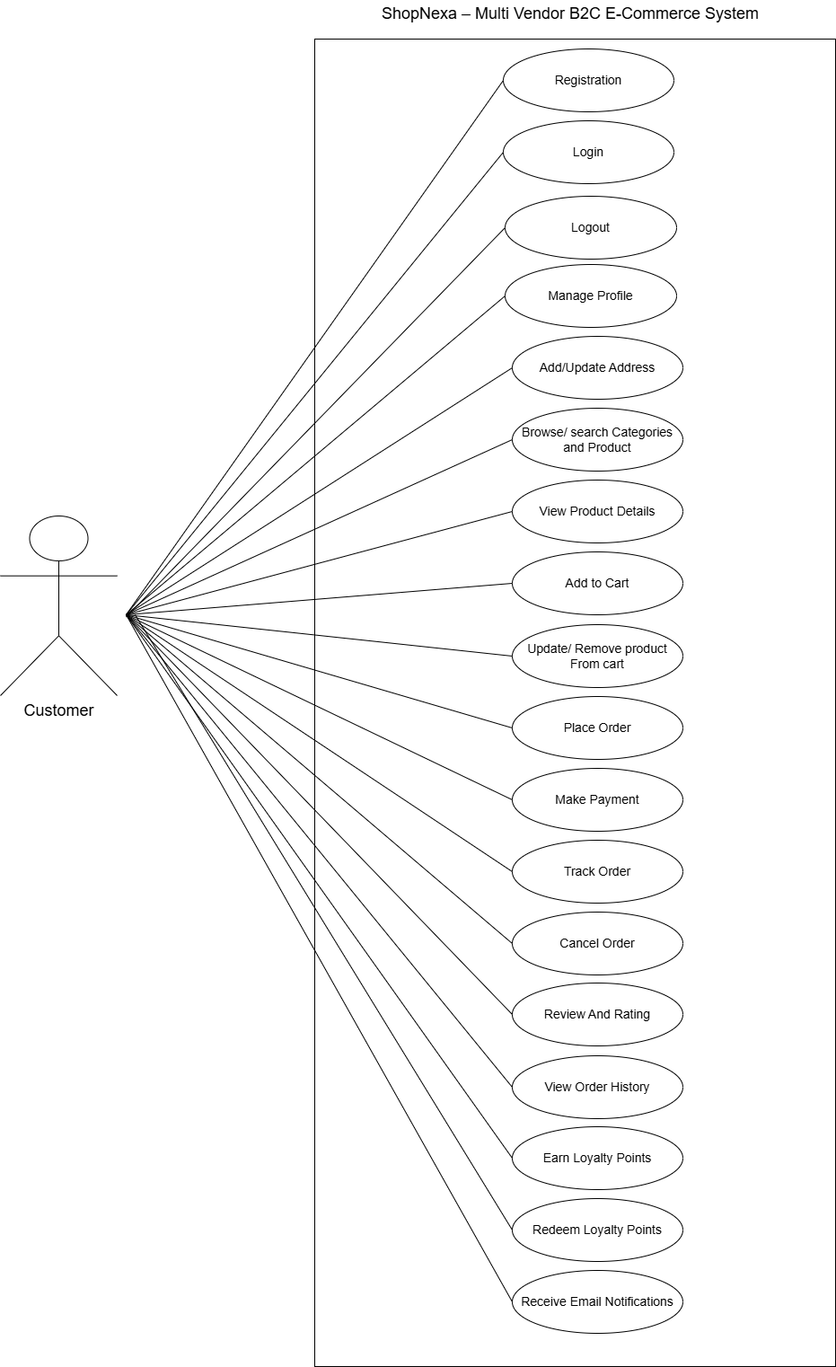
7.2 Vendor

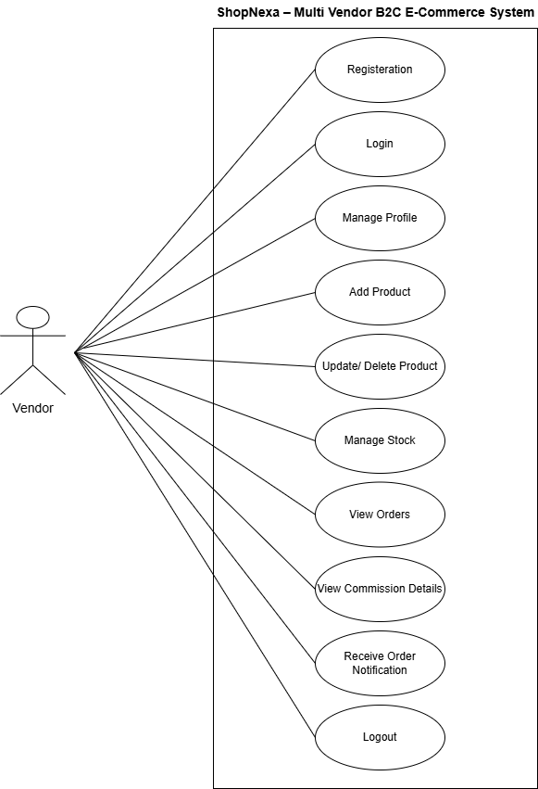
7.3 Admin

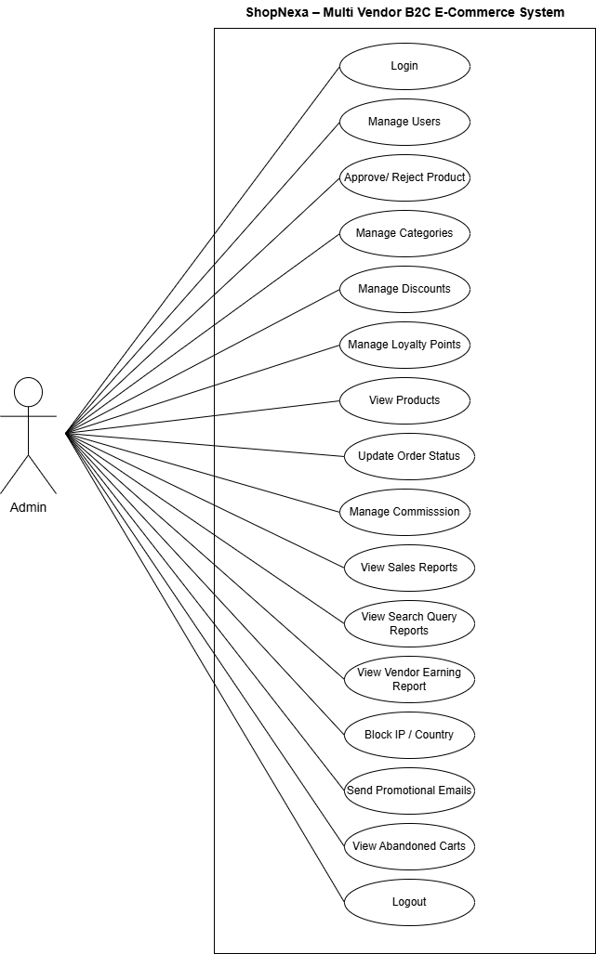
7.3 Guest

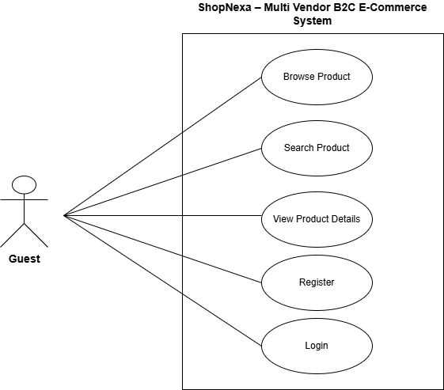
7.4 Payment Gateway

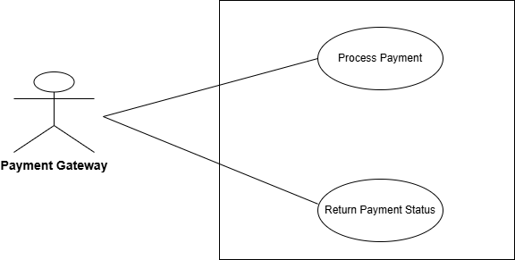

8. DFD Diagram
Context Level:
